

programmIng 2 fInal project

REPORT



https://github.com/HamdiKucuk298/Minesweeperrrr

My name is Hamdi Küçük.

I am presenting my Minesweeper game as my final project.

**Minesweeper is a single-player computer game that was first released by Microsoft on October 8, 1990. The objective of the game is to uncover all the empty squares on the board without clicking on any mines. The numbers that appear when a square is clicked indicate the total number of mines in the surrounding eight squares.**

**In this version of the game, each square has a 20% chance of containing a mine. If a player clicks on a mine, the game restarts. Unlike the traditional version, placing flags to mark suspected bombs is not allowed. Therefore, players must proceed with caution.**





hamdı kucuk

signature:

ıd:23040102043

ISTANBUL TOPKAPI UNIVERSITY

Our game starts after authentication. The interface displaying the Play and Exit options of our game is presented below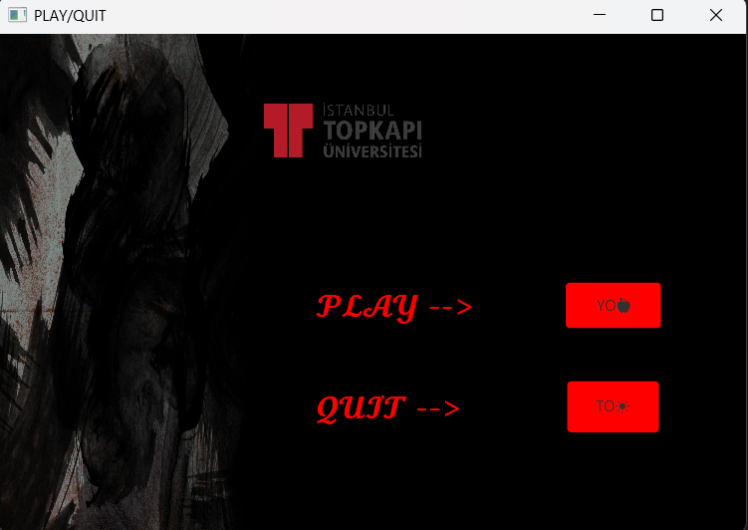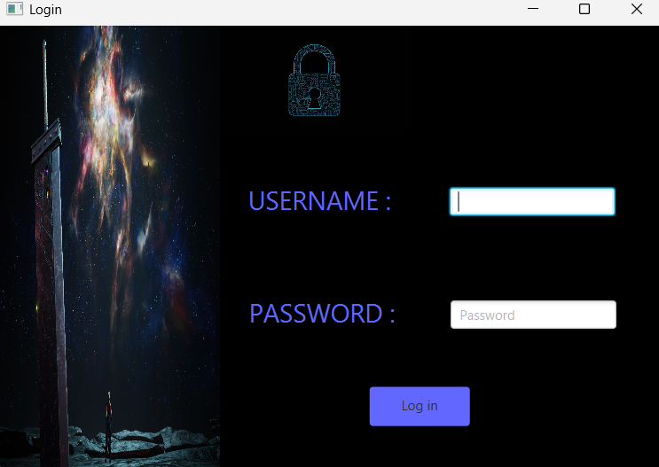

Upon starting the game, the interface appears as shown below, featuring a structured and detailed layout.

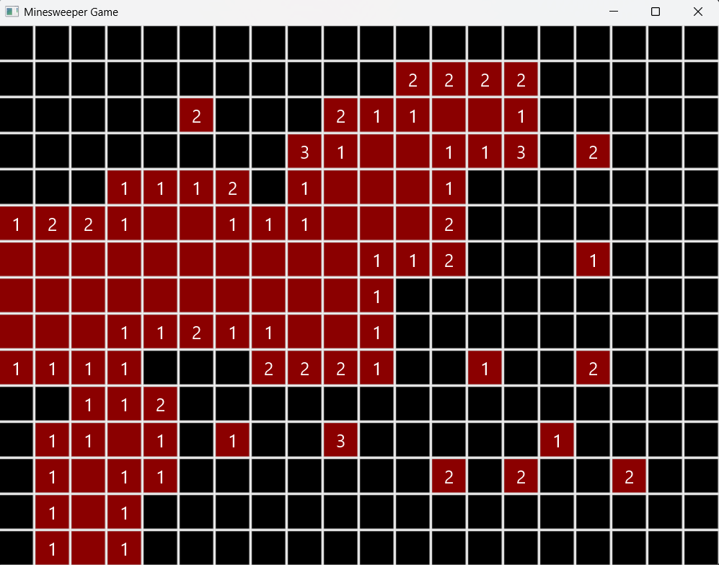

The game refreshes with each playthrough. Enjoy the experience in a 300-tile game area.

|  |  |  |
| --- | --- | --- |
| **Feature** | **Successfully realized (Yes or No)** | **Source code file names** |
| Basic functionality | Yes | Main.java, GameExe.java |
| Authentication | Yes | |  | | --- | |  |  |  | | --- | | LoginController.java, Login.fxml | |
| File processing | Yes | SampleController.java, Sample.fxml, application.css |
| **Additional features (if any):** |  |  |
| 1st Additional feature | No |  |
| 2nd Additional feature | No |  |
| ….. |  |  |
|  |  |  |

Note: The project contains image resources in the “resources/images” folder used for the game interface.